**Clone repository**

Shit + ctrl +p -> open git clone

1. Go to source control in VS and click in Clone repository
2. Go to github and copy the link as shown below

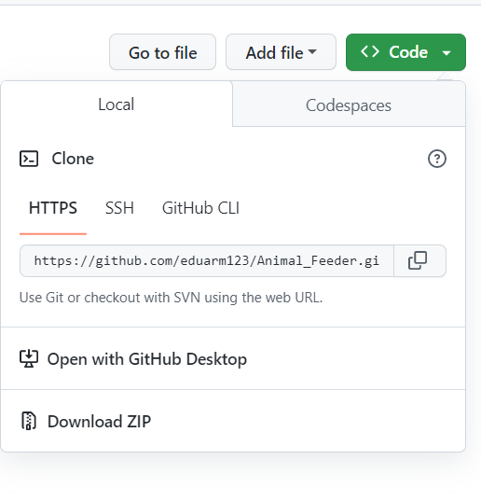

**Git stage changes and**

**Git Commit**

**Git push changes**

1. Just click in the button below



**To filter out files that we do not want**

To filter out files that you do not want to push to GitHub from your Visual Studio Code workspace, you can create a .gitignore file in the root of your repository. This file contains a list of patterns that Git should ignore when you push changes to the remote repository.

To create a .gitignore file, follow these steps:

1. In Visual Studio Code, open the terminal by clicking on "Terminal" in the top menu and selecting "New Terminal".
2. In the terminal, navigate to the root of your repository.
3. Type **New-Item -ItemType file .gitignore** and press enter. This will create a new .gitignore file in the current directory.
4. Open the .gitignore file in Visual Studio Code.
5. Add the names of the files or directories that you want to ignore, one per line. For example, if you want to ignore files that are generated when you compile a C project, you might add the following lines to your .gitignore file:

*.o

*.out

*.exe

1. Save and close the .gitignore file.

Once you have created your .gitignore file, Git will automatically exclude the files and directories that you have specified when you push changes to the remote repository.